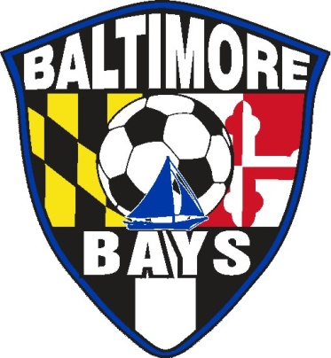

BALTIMORE BAYS PLAYERS CODE OF CONDUCT

I, ___________________________________________________, shall:

- Train hard and play to the best of my ability;
- Have a positive attitude and never quit;
- Win without boasting;
- Respect officials and accept their decisions;
- Exemplify sportsmanship;
- Only give encouragement to my fellow teammates;
- Attend and be prompt to all games and practices;
- Immediately report any injury to my coach;
- Respect my coach, my team’s officials, and my opponents;
- Learn and obey the laws of the game;
- Develop a personal practice/training routine for basic soccer skills and conditioning;
- Notify the coach or team official if I am unable to attend a game, training session, or team meeting;
- Learn the rules, policies, and procedures of the team and the Club;
- Comply with the elements of the Baltimore Bays Policy Manual;
- Never engage in dissent directed toward an official;
- Never use profane or vulgar language;
- Never use a controlled substance unless prescribed by a physician;
- Recognize that wearing the Baltimore Bays uniform is a privilege and always ensure that it is well kept and clean, with my jersey tucked in at all times;
- Never leave a game or training session without the permission of my coach or a team official;
- Never make excuses if my team loses;
- Never forget that in competition, I represent my team, the Baltimore Bays Soccer Club, the Baltimore area, and the state of Maryland at local, regional, national, and international levels.

Player signature: _______________________________________________________

Player printed name: ___________________________________________________

Team name: __________________________________________________________

Coach’s name: ________________________________________________________

