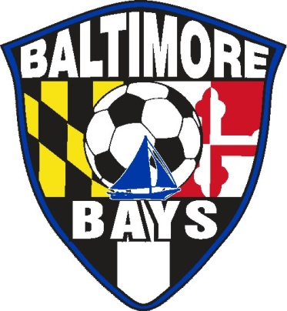

BALTIMORE BAYS PARENTS CODE OF CONDUCT

I, ________________________________________________, hereby pledge to provide positive support, care, and encouragement for my child participating in youth sports by following this code of ethics:

- I shall encourage good sportsmanship by demonstrating positive support for all players, coaches, and officials at every game, practice, team, or Club event.
- I shall place the emotional and physical well being of the player ahead of any personal desire to win.
- I shall insist that my child play in a safe and healthy environment.
- I shall provide support for coaches, team and Club officials, working with my child to provide a positive, enjoyable experience for all.
- I shall demand a drug-, alcohol-, and tobacco/smoke-free sports environment for my child and agree to assist by refraining from their use at all youth soccer events.
- I shall remember that the game is for the children, not the adults.
- I shall do my best to make youth soccer fun for my child.
- I shall ask my child to treat other players, coaches, fans, and officials with respect.
- I shall promise to help my child enjoy the youth soccer experience within my personal constraints by assisting with team and Club activities, being a respectful fan, or whatever it takes or I am capable.
- I shall require that my child’s coach be trained in the responsibilities of being a youth soccer coach and that the coach agree to the coach’s responsibilities outlined by the Baltimore Bays.
- I shall do everything in my power to assist in the implementation of and adherence to the Parents Code of Conduct and continue the Baltimore Bays Soccer Club Traditions.

Parent(s) signature: ______________________________________________________________________

Player name: ______________________________________________________________________

Team name:
______________________________________________________________________

Coach’s name:
______________________________________________________________________

